[CDF Ambassador Program 2020](https://cd.foundation/ambassador-program-overview-application/)

Nov 4, 2020

About the Program

The CDF Ambassador Program is a network of 51+ passionate community leaders, CD industry representatives, thought leaders, and meetup super organizers. These volunteers are committed to empowering their local communities with skills, education and support in CD & DevOps. These individuals include: industry influencers, enterprise practitioners, consultants, bloggers, analysts, advocates, community builders, local event organizers and evangelists. 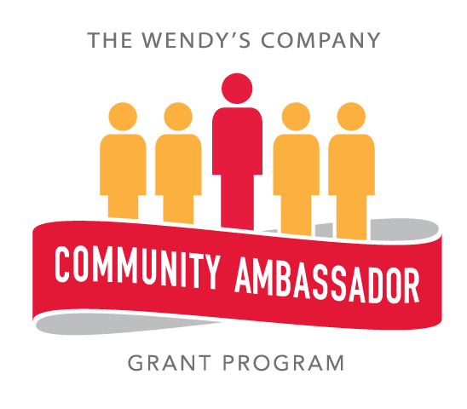

CDF Community Ambassadors are individuals who are passionate about the Continuous Delivery Foundation technology and projects, recognized for their expertise in, and willingness to help others learn about the framework and community

The CDF Community Ambassador program aims to and evangelize the CDF by advocating the [9 strategic goals](https://cd.foundation/blog/2019/10/17/cdfs-governing-board-unveils-9-strategic-goals/) established by the governing board in 2019. Successful ambassadors are individuals that are interested & already help coordinate local and regional meetups, create educational content such as blogs, whitepapers, case studies, or training. The CDF Community Ambassador program exists to empower community members with tools and resources needed to:

* Promote CD open source projects and technology
* Educate a local community on the CDF mission
* Contribute to CDF projects

## Requirements for becoming an official CDF Community Ambassador:

* Affiliated with a CDF member OR is a contributor to a CDF project
* Willing to either speak at community events OR write technical articles for the CDF newsletter or blog
* Host a CDF community group/meetup.
* Event support
* Willing to either speak at the CDF Podcast OR Webinar Program

## Expected Time Commitments:

* Give a talk, host a meetup or perform an activity that spreads awareness of CD four times a year
* Report back your activities for our end-of-year survey and report

## FAQ

How often are ambassador applications reviewed?

Do I need to re-apply?

Will you email me with a status update of my application each month?

I'd like to get in touch with the CNCF ambassador in a specific city/region. Where can I find who is a local ambassador?

What if I want to step down or don't have the time to commit anymore?

## About the CD Foundation

The Continuous Delivery Foundation (CDF) serves as the vendor-neutral home of many of the fastest-growing projects for continuous integration/continuous delivery (CI/CD). It fosters collaboration between the industry’s top developers, end users and companies to further CI/CD best practices and industry specifications. Its mission is to grow and sustain projects that are part of the broad and expanding continuous delivery ecosystem.

With respect to values and principles driving the Foundation, the Foundation:

* believes in the power of Continuous Delivery to empower developers and teams and to produce high quality software more rapidly;
* believes in the open source solutions collectively addressing the whole software delivery lifecycle;
* fosters and sustains the ecosystem of open-source, vendor neutral projects through collaboration and interoperability; and
* advocates these principles and encourages collaborations among practitioners to share and improve their practices.

CDF will have an open governance model that encourages participation and technical contribution and will provide a framework for long-term stewardship and sustainability for CI/CD tools.

The CDF will evangelize CI/CD methodologies, define/document best practices, and create training materials to enable software development teams around the world to deliver code changes faster and more reliably. The CDF will also provide software development teams with an OSS-based, open development model.

## CD Foundation Community Ambassador Benefits

* Special promotion of your status as a CDF Community Ambassador & personal brand through content: blogs, podcasts, webinars, events and talks.
* Special recognition: as a selected ambassador you will have access to a [[digital badge](https://www.canva.com/design/DAD3kayE3WU/42HmKP55qeLIAduK4WXu1w/view?utm_content=DAD3kayE3WU&utm_campaign=designshare&utm_medium=link&utm_source=publishsharelink)], kit [t-shirt & decals from each of CDF projects]
  + Badge will denote open source project expertise
  + CDF t-shirt
  + Free swag for your Meetup group

Example of digital badge:

* 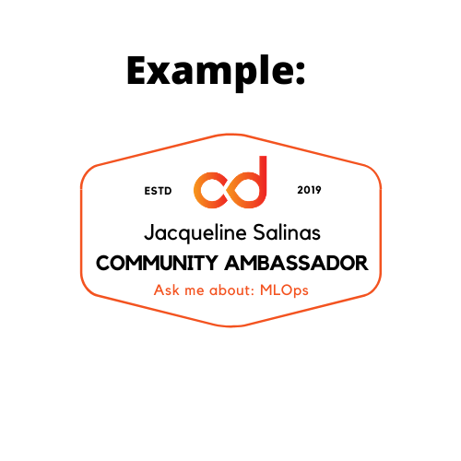Access to the global CDF Community Ambassador community through a dedicated mailing list [groups.io], Slack channel, CDF Ambassador landing page, discussion forums, and LinkedIn group.
* Priority assistance: global CDF Community Ambassadors & Director of Ecosystem.
* Advance notice of podcasts, newsletters, events, CFPs, webinars, and blogs.
* Assistance with community networks: mailing lists and discussion forums.
* Opportunity to influence the direction of community-produced resources.
* Opportunity to meet, interview, and interact w/CDF member leaders, GB, Outreach Committee, SIGs, and TOC
* Need based applicants can submit for free CDF hosted event ticket & travel stipend

## More benefits include:

* Complimentary collateral: digital copies of case studies, annual report, community content, podcast, webinars, etc. for community distribution.
* Invitations: monthly ambassador calls and annual in-person gathering.
* Opportunities: network with the ambassadors and CDF network to extend professional connections
* Discounted or free attendance at CDF events
* Quarterly and yearly awards:
  + Highest Meetup Membership Growth
  + Super Host (2 categories)
    - Of the Quarter (hosted 3+)
    - Of the Year (4+)
  + Speaker of the Year
  + Blogger of the Year
  + Contributor of the Year
  + Ambassador of the Year

## CD Foundation Community Ambassador Commitment

* **The Community Go-To Resource for People Interested in CDF**: As a Community Ambassador, you will be an important resource to people interested in the CDF and its corresponding projects. We will provide you with training on how to best represent the CDF and provide discount codes for you to attend CDF-sponsored events.
* **Help Local Users Learn More About CDF**: As a Community Ambassador, you will organize and host a local CDF Users Group meetup. The CDF will provide resources to help you set up your meetup and ongoing support such as swag credits and reimbursements for costs associated with running community events.
* **Represent the Community Publicly**: As a Community Ambassador, you will be a public-facing community representative. You can choose the way you are most comfortable representing CDF, whether that’s through public speaking or written content such as blogs. We will work with you to find the best fit and provide you with resources to help you be successful as either a speaker, a writer, or both!

## CD Foundation Community Ambassador Roles & Responsibilities

## The CD Foundation Community Ambassador’s play a crucial role in supporting, growing and engaging the developer community with a variety of resources. In order for the CD Foundation to offer free educational content, speaking or training opportunities, and facilitate engagement we need global volunteers to help us coordinate and execute on our behalf. The CD Foundation Community Ambassador minimum responsibilities include at least 1 of the following activities:

* Publish 4 or more of the following: podcast, blog, webinar, and/or article per year.
* Help stand up local and/or regional Meetup groups and events.
  + Organize 4 or more Meetup events per year
* Give 4 or more talks about CDFs open source projects: Jenkins, JenkinsX, Tekton, Spinnaker, and/or Screwdriver

Additional Roles:

* Support and promote CDF and affiliated projects on social media (Twitter & LinkedIn)
* Review training or course materials, promotional/marketing content, and/or event program when applicable
* Participate in CD Summits, CDCon, and MIndShare Cocktail Hour
* Help develop innovative ways to increase member engagement and experience
* Follow the code of conduct

## CD Foundation Community Ambassador Role Duration

## All new CD Foundation Community Ambassadors will have a provisional designation for 2 quarters. Upon successful completion of the 2 quarters, ambassadorship extends to 4 quarters. Then, ambassador roles are renewed yearly based on outcomes.

## Code of Conduct

## All program and event participants are expected to behave in accordance with professional standards, with both this Code of Conduct as well as their respective employer’s policies governing appropriate workplace behavior and applicable laws. The Linux Foundation and its project communities are dedicated to providing a harassment-free experience for participants at all of our programs and events. Linux Foundation programs and events are working opportunities intended for professional networking and collaboration within the open source community. They exist to encourage the open exchange of ideas and expression and require an environment that recognizes the inherent worth of every person and group. While at Linux Foundation programs and events or related ancillary or social events, any participants, including members, speakers, attendees, volunteers, sponsors, exhibitors, booth staff and anyone else, should not engage in harassment in any form. All event participants are expected to behave in accordance with professional standards, with both this Code of Conduct as well as their respective employer’s policies governing appropriate workplace behavior and applicable laws.

## This Code of Conduct may be revised at any time by The Linux Foundation and the terms are non-negotiable. Your registration for or participation at any Linux Foundation program or event indicates your agreement to abide by this policy and its terms.

### Expected Behavior

## All event participants are expected to behave in accordance with professional standards, with both this Code of Conduct as well as their respective employer’s policies governing appropriate workplace behavior and applicable laws.

### Unacceptable Behavior

## Harassment will not be tolerated in any form, including, but not limited to, harassment based on gender, gender identity and expression, sexual orientation, disability, physical appearance, body size, race, age, religion or any other status protected by laws in which the conference or program is being held. Harassment includes the use of abusive, offensive or degrading language, intimidation, stalking, harassing photography or recording, inappropriate physical contact, sexual imagery and unwelcome sexual advances or requests for sexual favors. Any report of harassment at one of our events will be addressed immediately. Participants asked to stop any harassing behavior are expected to comply immediately. Anyone who witnesses or is subjected to unacceptable behavior should notify a program or conference organizer at once.

## Individuals who participate (or plan to participate) in Linux Foundation programs and events should conduct themselves at all times in a manner that comports with both the letter and spirit of this policy prohibiting harassment and abusive behavior, whether before, during or after the event. This includes statements made in social media postings, online publications, text messages, and all other forms of electronic communication.

### Consequences of Unacceptable Behavior

## If a participant engages in harassing behavior, the program or conference organizers may take any action they deem appropriate depending on the circumstances, ranging from issuance of a warning to the offending individual to expulsion from the conference with no refund. The Linux Foundation reserves the right to exclude any participant found to be engaging in harassing behavior from participating in any further Linux Foundation programs, events, training or other activities.

## If a participant (or individual wishing to participate in a Linux Foundation event), through postings on social media or other online publications or another form of electronic communication, engages in conduct that violates this policy, whether before, during or after a Linux Foundation event, the Linux Foundation may take appropriate corrective action, which could include imposing a temporary or permanent ban on an individual’s participation in future Linux Foundation programs and events.

### What To Do If You Witness or Are Subject To Unacceptable Behavior

## If you are being harassed, notice that someone else is being harassed, or have any other concerns relating to harassment, please contact a member of the program or conference staff immediately. Please contact Jacqueline Salinas, Director of Ecosystem, at jsalinas@cd.foundation.

### Incident Response

## Our staff has taken incident response training and responds to harassment reports quickly and thoroughly. As referenced above, if a participant engages in harassing behavior, the program and conference organizers may take any action they deem appropriate, ranging from issuance of a warning to the offending individual to expulsion from the program or conference with no refund, depending on the circumstances. The Linux Foundation reserves the right to exclude any participant found to be engaging in harassing behavior from participating in any further Linux Foundation programs, events, training or other activities.

[CDF Ambassador Overview & Application page](https://cd.foundation/ambassador-program-overview-application/)

[CDF Community Ambassador Cohort](https://cd.foundation/ambassador-program-overview-application/community-ambassador-cohort20/)

**CDF Monthly Ambassador Call:**

* [Google cal invite](https://calendar.google.com/event?action=TEMPLATE&tmeid=dWZ2c3BoN2NnMW5lcTE5YXIzdTRuOWd1cXBfMjAyMDExMThUMTYwMDAwWiBsaW51eGZvdW5kYXRpb24ub3JnX21oZjBrbWdlZG42N2lobmk4cjEyOWF2cDI0QGc&tmsrc=linuxfoundation.org_mhf0kmgedn67ihni8r129avp24%40group.calendar.google.com&scp=ALL)
* Every 3rd Wednesday of the month @ 8am PST

**About the CD Foundation**

*Continuous delivery (CD) is a software engineering approach in which teams produce software in short cycles, ensuring that the software can be reliably released at any time. The Continuous Delivery Foundation (CD Foundation) serves as the vendor-neutral home of many of the fastest-growing projects for continuous delivery, including Jenkins and Jenkins X, as well as fosters collaboration between the industry’s top developers, end users and vendors to further continuous delivery best practices. CD Foundation is part of The Linux Foundation, a nonprofit organization. For more information about the CD Foundation, please visit* [*https://cd.foundation*](https://cd.foundation)*.*

Copyright © 2020 The Linux Foundation®. All rights reserved. The Linux Foundation has registered trademarks and uses trademarks. For a list of trademarks of The Linux Foundation, please see our Trademark Usage page. Linux is a registered trademark of Linus Torvalds.